LAB 08

200356A

Screenshots

Using the user input same as the sample input given [4,17,3,12,9,6]

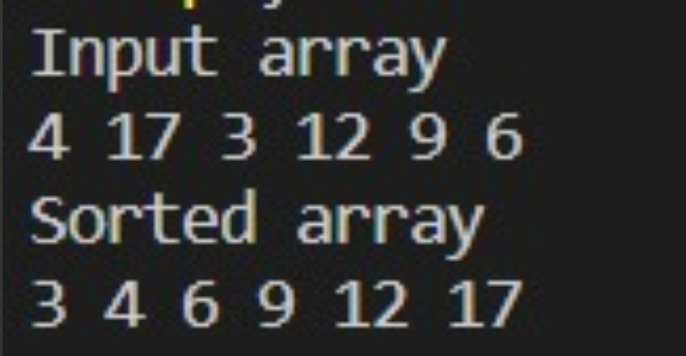

Time complexity for heap sort is O(nlog(n)).

For building heap it needs O(nlog(n)) and for sorting It needs O(nlog(n)).